**How to: Create a SQL Server Database using SQL Server 2008 R2**

**Siddheshwar Software**

Nilesh Khendke

https://codecanyon.net/user/mahesh99

4/20/2020

**Download and install Microsoft SQL server 2008 R2, if you don't have the version.**

**Step-1**

Please download Microsoft SQL Server 2008 R2

<https://www.microsoft.com/en-us/download/details.aspx?id=23650>

**Step-2**

Follow how to install Microsoft SQL Server 2008 R2 on your machine.

<https://www.youtube.com/watch?v=UaOwvsnL9Ps>

**Step-3**

Follow how create SQL server database.

<https://www.youtube.com/watch?v=gyBT75-5lV4>

**How to create SQL server database?**

**SQL Server provides two methods for creating database user accounts:** Windows authentication or mixed mode, which supports Windows authentication and SQL Server authentication. In Windows authentication mode, you assign all database permissions to Windows accounts. This has the advantage of providing a single sign-on experience for users and of simplifying security management. In SQL Server (mixed mode) authentication, you can still assign rights to Windows users, but you can also create accounts that exist only in the context of the database server.

**Step-1**

* To open SQL Server Management Studio 2008 R2, right-click the SQL Server Management Studio icon on the **Start** menu, and then click **Run as Administrator.**
* 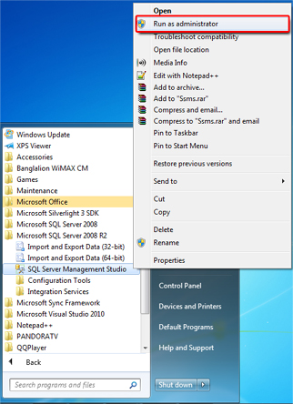
* Select Server type: **Database Engine**, Server Name: **(local)**, Authentication: **Windows Authentication**
* Click **Connect**

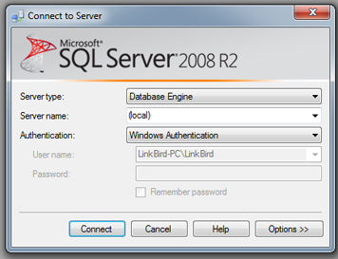

**Step-2**

* After login SQL server management studio, Right click on **Database** folder and click **New Database …**
* New database window will appear

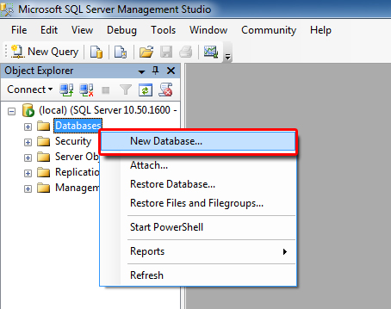

**Step-3**

* Provide database name (**SERP**) in the database name text box.
* Scroll right database file grid view & find out path header; clickfor put your database file and database log file into same folder. Default path is C:\Program Files\Microsoft SQL Server\MSSQL10_50.MSSQLSERVER\MSSQL\DATA
* If a path is specified, click **OK** button

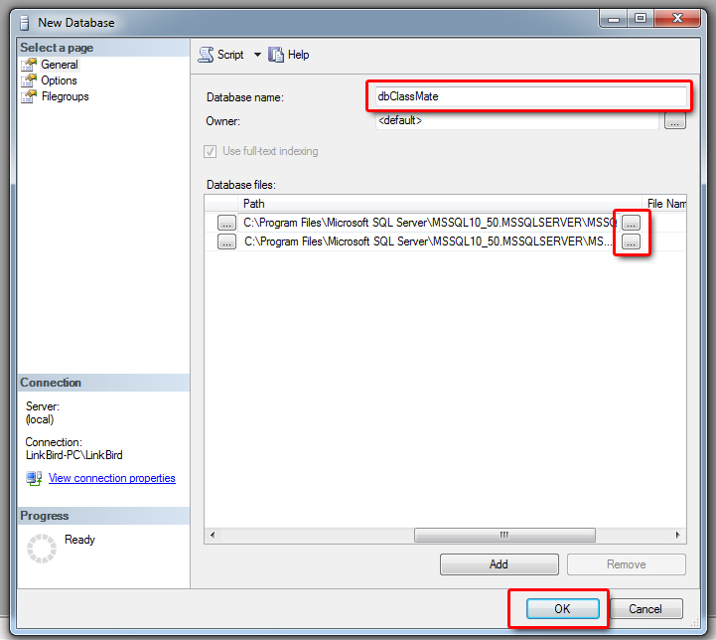

SERP

**Step-4**

* Once finished, click & expand database folder.
* Right click on **SERP** and click **New Query**

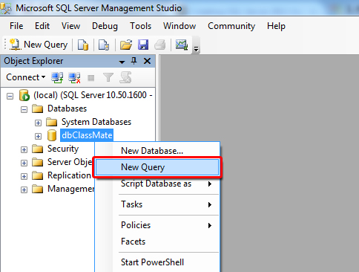

SERP

**Step-5**

* Copy all text from **Blank-Script-School-Original.sql** files for blank project OR if want sample data then copy this **Script-With-Data.sql** with note pad, copies all code and paste into New Query Panel and press **F5** or **Execute**

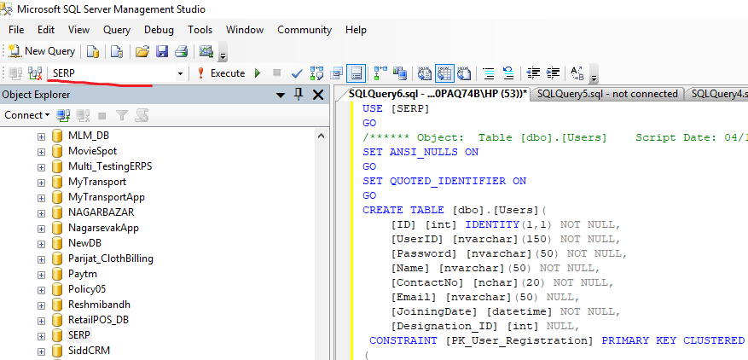

**Step-6**

* Once Query executed successfully, Right click on SQL Server and click Refresh.
* Expand **Databases - > SERP -> Tables**

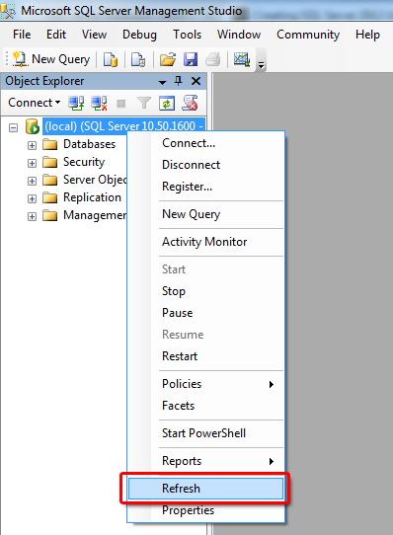

Please drop us a note with your feedback, suggestions or questions. For technical support or general queries you can contact us via: Email: nilesh.khendke@gmail.com

**DON’T FORGET TO RATE THIS ITEM**

**Login to CodeCanyon - -> Open the menu on the top right --> Rate our items using the stars -->That’s it. Thank you very much!**